T.C. Williams High School

Honors Biology

Mr. Ben Matthews
Room 210
Best time to reach me: 3:15-4:10
Office hours: Wednesday/Thursday after school from 3:15-4:30 and by appointment
benjamin.matthews@acps.k12.va.us
(703) 824-6750
Twitter: @TCBioTeacher, @TCW_STEM

Syllabus

Course Description:
This inquiry-based course, students in the STEM Academy will learn to address real-world issues by conducting laboratory investigations and research-based projects. Students will use the lens of Sustainability to investigate the dynamic relationships between organisms and how they change over time. An emphasis will be placed on students working collaboratively to address real-world issues and develop solutions that are evidence-based. All students will be required to develop a project for the ISEF Science Fair competition that focuses on science, technology, and innovation. All students will take the End of Course Biology Standards of Learning Assessment at the end of the year.

The Rules:
Rule #1 — Respect your peers, your teachers and staff, and yourself.
Rule #2 — Bring all materials to class.
Rule #3 — NO FOOD OR DRINK in the classroom.
Rule #4 — Do NOT interfere with another’s learning.

The Materials: Please bring the following materials to class…
1. A 1-inch 3 ringed binder to keep all of the handouts and your table of contents.
2. Notebook paper to put in your binder.
3. Pens or pencils to take notes.
4. Sketch Book for warm ups and Science Journaling.

Additionally, you should bring your charged Chromebook and student agenda book to class every day. Many class assignments, laboratory experiments, and projects are on the computer – make sure that you are prepared to take advantage of this great resource that is provided to you!

Canvas and Google Classroom: All course materials will be posted on Google Classroom until Canvas is fully set up.

How to get help and stay organized:
- Before and after school tutoring
- Writing Center

How to improve your grade: Students are expected to demonstrate effort towards improving their grade. Above all, a strong work ethic is rewarded in my class. Every student may revisit work UP UNTIL the END OF THE UNIT OF STUDY. Revisiting work does not mean the grade for that assignment will change, but it will however prepare students for the Unit Assessments which carry the most weight.

When will I have assignments to complete at home? Or any other area of importance for your course.
- Expect home assignments on a daily basis.
- Any late assignment due to an unexcused absence will follow ACPS Guidelines. You may complete the work for that assignment and submit it at any time until the end of that unit of study, but cannot redeem full credit.
- All MISSED ASSIGNMENTS will be able to be made up for full credit when due to an EXCUSED ABSENCE. Due Dates will be determined by the teacher.

Grading Criteria:
Level 1: Tests/Quizzes/Projects = 50%
Level 2: Labs/Activities = 25%
Level 3: Science Fair = 15%
Level 4: Assignments = 10%

Unit 1 (Q1): Sustainability and Ecology – Living on the Earth, Planning for OUR Future
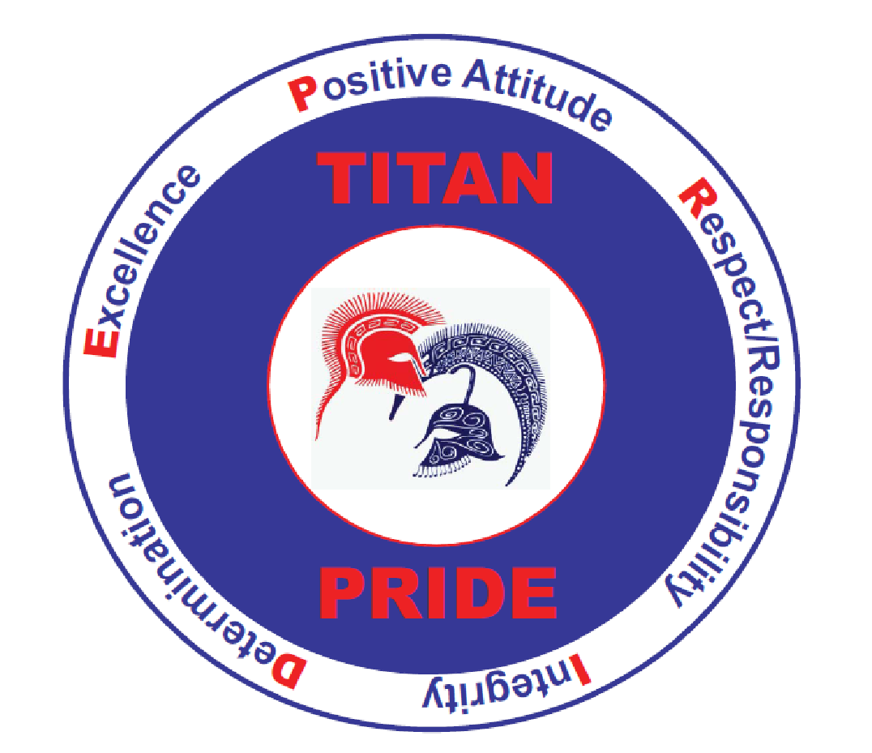
This unit serves as a foundation for the entire course. Students will be introduced to the context for the entire course: Sustainability: Will it Last? Students will examine several case studies, identify global sustainability issues, engage in classroom discussions, and investigate a hypothetical sustainability issue from a variety of perspectives. Additionally, students will examine a variety of ecological issues including the impact of human activities on ecosystems. Topics will include invasive species and the impact they have on established ecosystems, wildlife management strategies, resource exploitation and the interconnectedness of the components that make up an ecosystem. Special emphasis will be placed on the Chesapeake Bay Watershed and the local activities and decisions that have an impact on this unique ecosystem.
Unit 2 (Q2): Cell Biology – World Health
In this unit students will explore a wide variety of topics through the lens of “World Health.” Infectious diseases have shaped the course of human history and continue to play a role in the sustainability of our global community. Students will explore the social, environmental, and economic consequences of infectious disease as well as the mechanisms of disease at the cellular level.
Unit 3 (Q3): Genetics – Bioethics and Application of Biotechnology
Students will explore inheritance through the ways in which modern scientists use our knowledge of genetics to have an impact on society. From enhancing crop productivity to producing new fuel types to treating disease, students will learn how the application of genetic knowledge is transforming our lives. Students will also delve into the many ethical issues surrounding the use of genetic information; these issues include the genetic modification of organisms and the protection of an individual’s right to maintain the privacy of their genetic information.
Unit 4 (Q4): Evolution – Maintaining Biodiversity
Students will explore the process of natural selection and its contribution to speciation through the lens of biodiversity. Students will examine the difference mechanisms of evolution and how they increase, decrease, or maintain biodiversity. Additionally, students will examine human’s social, environmental, and economic influences on biodiversity to help make decisions that support sustainable practices for the future.

Honor Code
The T.C. Williams administration and teachers consider cheating, plagiarism, and other examples of academic dishonesty to be a serious breach of academic integrity by the students. The ACPS Student Guidelines provide that the Alexandria City Public School students are expected to perform honestly through the production of their own work. They should demonstrate respect for the belongings and rights of others. Students should not cheat, plagiarize, or knowingly make false statements with respect to any assigned schoolwork or tests, or provide a student the opportunity to do so.

I have read the attached syllabus with my student (name)_________________________________

Parent Name(s):

Parent Signature:

Email (if applicable):

Phone Number(s):

Home :

Cell:

Work:

